First half : backend API

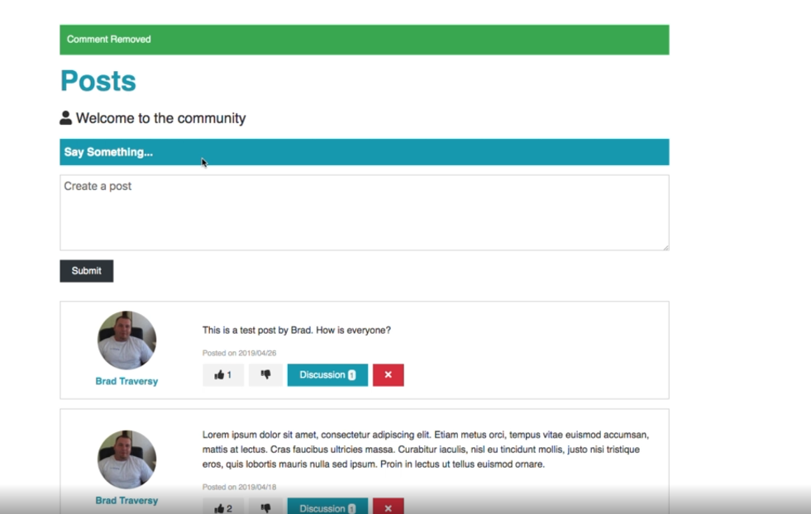

Project making using mern.

Second half : react , redux for state management.

Github project link :

